# *Fundamentals of programming*

## *Assignment#2*

Name: Muhammad Usman Bhutto

Cms Id: 453891

Section: B

Date: 9/10/2023

***Home task #1:***

1. Create a program that takes a student's score as input and assigns a grade based on

predefined criteria using logical operators (e.g., A, B, C, D, F).

A-Grade: 90-100 Marks

B-Grade: 75-90 Marks

C-Grade: 60-75 Marks

D-Grade: 45-60 Marks

F-Grade: 0-45 Marks

***Answer:***

#include<iostream>

using namespace std;

int main()

{

float score;

cout<<"enter your score:";

cin>>score;

if(score>90&&score<=100)

{

cout<<"you have scored A grade:";

}

if(score>75&&score<=90)

{

cout<<"you have scored B grade:";

}

if(score>60&&score<=75)

{

cout<<"you have scored C grade:";

}

if (score>45&&score<=60)

{

cout<<"you have scored D grade:";

}

if(score>=0&&score<=45){

cout<<"you have scored F grade:";

}

return 0;

}

*Output:*

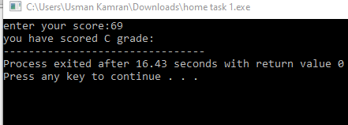

***Home task #2:***

1. Write a program that takes an integer as input and determines if it is both even and divisible by 5.

***Answer:***

#include<iostream>

using namespace std;

int main()

{

int number;

cout<<"enter your number:";

cin>>number;

if(number%2==0&&number%5==0)

{

cout<<number<<" is both even and divisible by 5"<<endl;

}

else

{

cout<<number<<" is not both even and divisible by 5";

}

return 0;

}

***Output:***

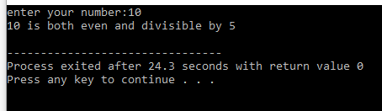

***Home task #3:***

3. Create a C++ program that checks if a user-provided year is a leap year.

***Answer:***

#include<iostream>

using namespace std;

int main()

{

int year;

cout<<"enter the year:";

cin>>year;

if ((year % 4 == 0 && year % 100 != 0) || (year % 400 == 0))

{

cout<<year<<"is a leap year";

}

else

{

cout<<year<<"is not a leap year";

}

return 0;

}

***Output:***

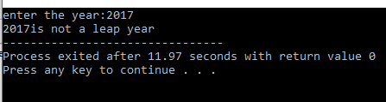

***Home task #4:***

4:Create a C++ program that determines if a student is eligible for a scholarship based on their GPA (must have GPA >= 3.5) and attendance (must have attended at least 80% of classes).

***Answer:***

#include<iostream>

#include<cmath>

using namespace std;

int main()

{

float GPA,attendance;

cout<<"enter your gpa and attendance:";

cin>>GPA>>attendance;

if(GPA>=3.5&&attendance>=80)

{

cout<<"you are eligible for scholarship";

}

else

{

cout<<"you are not eligible for scholarship";

}

return 0;

}

***Output:***

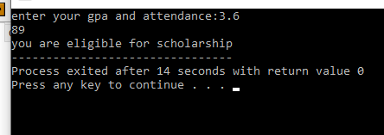

***Home task#5:***

1. Write a program that checks if a given character is a vowel (a, e, i, o, u) or a consonant using logical operators.

***Answer:***

#include <iostream>

int main() {

char ch;

// Prompt the user for input

std::cout << "Enter a character: ";

std::cin >> ch;

// Convert the character to lowercase (to handle both uppercase and lowercase)

ch = tolower(ch);

// Check if it's a vowel or a consonant

if ((ch >= 'a' && ch <= 'z') && (ch == 'a' || ch == 'e' || ch == 'i' || ch == 'o' || ch == 'u')) {

std::cout << ch << " is a vowel." << std::endl;

} else if (ch >= 'a' && ch <= 'z') {

std::cout << ch << " is a consonant." << std::endl;

} else {

std::cout << "Invalid input. Please enter a valid lowercase or uppercase character." << std::endl;

}

return 0;

}

***Output:***

